1)
#include <stdio.h>
#include <stdlib.h>
#include <string.h>

char * longestCommonPrefix(char ** strs, int strsSize){
if(strsSize == 0) return "";
int prefixLen = strlen(strs[0]);
for(int i=1; i<strsSize; i++){
int j=0;
while(j<prefixLen && strs[i][j]==strs[0][j]){
j++;
}
prefixLen = j;
}
char *prefix = (char*)malloc(sizeof(char)*(prefixLen+1));
strncpy(prefix, strs[0], prefixLen);
prefix[prefixLen] = '\0';
return prefix;
}

int main(){
char *strs[] = {"flower","flow","flight"};
int strsSize = 3;
char *prefix = longestCommonPrefix(strs, strsSize);
printf("Longest Common Prefix: %s\n", prefix);
return 0;
}
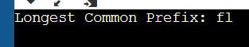

2)
#include <stdio.h>

int binarySearch(int arr[], int l, int r, int x) {
while (l <= r) {
int mid = l + (r - l) / 2;
if (arr[mid] == x)
return mid;
if (arr[mid] < x)
l = mid + 1;
else
r = mid - 1;
}
return -1;
}

int main() {
int arr[] = { 2, 3, 4, 10, 40 };
int n = sizeof(arr) / sizeof(arr[0]);
int x = 10;
int result = binarySearch(arr, 0, n - 1, x);
(result == -1)
? printf("Element is not present in array")
: printf("Element is present at index %d", result);
return 0;
}
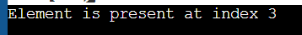

3)
#include <stdio.h>

int main() {
int n, arr[20], i, j, temp; // fixed variable declaration and removed extra comma
printf("Enter number of elements of the array: ");
scanf("%d", &n); // fixed format specifier for integer input

for (i = 0; i < n; i++) {
printf("Enter an element of the array: ");
scanf("%d", &arr[i]); // fixed format specifier for integer input
}

for (i = 0; i < n - 1; i++) {
for (j = 0; j < n - i - 1; ++j) { // fixed variable name and array size
if (arr[j] > arr[j + 1]) {
temp = arr[j];
arr[j] = arr[j + 1];
arr[j + 1] = temp;
}
}
}

printf("Array after implementing Bubble sort: ");
for (i = 0; i < n; i++) {
printf("%d ", arr[i]); // fixed format specifier for integer output and added space
}
printf("\n"); // added newline character

return 0;
}
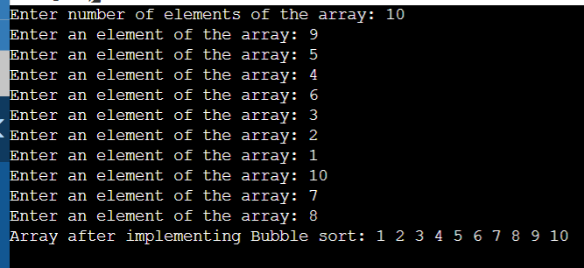
4)
#include <stdio.h>

int multiply(int number1, int number2); // function prototype for multiply function
int addition(int number1, int number2); // function prototype for addition function

int main() {
int number1; // first number
int number2; // second number
int result_multiply;
int result_addition;

printf("Please enter first number: ");
scanf("%d", &number1);

printf("Please enter second number: ");
scanf("%d", &number2);

result_multiply = multiply(number1, number2);
printf("Multiplication of the two numbers is %d\n", result_multiply);

result_addition = addition(number1, number2);
printf("Addition of the two numbers is %d\n", result_addition);

return 0;
}

int multiply(int number1, int number2) {
return number1 * number2;
}

int addition(int number1, int number2) {
return number1 + number2;
}
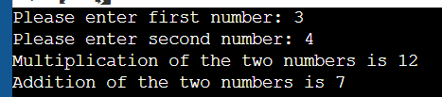
5)
#include <stdio.h>

int main() {
int arr[] = {1, 9, 2, 7, 6, 3, 5, 10, 4, 8};
int n = sizeof(arr) / sizeof(arr[0]);

for(int i = 0; i < n; i++) {
while(arr[i] != i+1) {
int temp = arr[arr[i]-1];
arr[arr[i]-1] = arr[i];
arr[i] = temp;
}
}

printf("Rearranged array: ");
for(int i = 0; i < n; i++) {
printf("%d ", arr[i]);
}

return 0;
}
